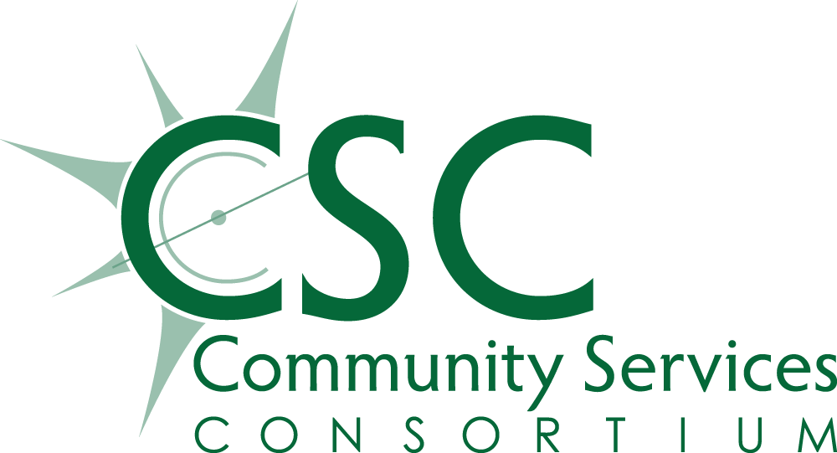
Request for Proposals
CSC Homeless Response Funds

Objective / Purpose
In response to the increasing needs of those experiencing homelessness in Linn, Benton, and Lincoln Counties, Community Services Consortium (CSC) is accepting proposals from community partner organizations for projects intended to provide shelter to the unhoused in our region. Per the regulations of the available state funds being passed through from Oregon Housing and Community Services by CSC to the successful sub-recipients, CSC is accepting proposals for the following activities:
Allowable activities and services are:
- Emergency Shelter – shelter operations, including shelter rent and utilities, security, fuel, equipment, insurance, food, furnishings, supplies and facility maintenance and minor repairs. May also include shelter services such as case management, counseling, assistance with housing search, and onsite health services.
- Motel Sheltering – only when used as a temporary shelter option when other shelters are full, unavailable in a given location, or unable to meet the needs of those with disabilities. Applicant must demonstrate how the motel guests are being assisted with finding alternative living situations, up to and including permanent housing placements.

NOTE: People experiencing homelessness shall not be required to receive treatment or perform any other prerequisite activities as a condition for receiving assistance funded by CSC.
Background
Community Services Consortium (CSC) is the community action agency serving Linn, Benton and Lincoln Counties. Since 1980, our mission has been, in partnership with a caring community, to help people access tools and resources to overcome poverty and build brighter, more stable futures. But no one can expect to overcome poverty without the foundation of decent, safe place to call home. Those who are unhoused are particularly vulnerable and have been disproportionately impacted by the recent COVID 19 pandemic. CSC acknowledges that there is an emergent need for shelter and in our communities and is targeting these vital funds to strengthen and enhance our region’s ability to address the immediate needs of those experiencing homelessness through coordinated partnerships.
Sub-Grantee Mandatory Requirements
To be considered for funding, the organization must be:
- Serving the unhoused in Linn, Benton, and/or Lincoln Counties;
- A 501(c)3 who has not been declared ineligible to receive Federal contracts by the GSA;
- Able to collect and report all required client data points into the state sanctioned Housing Management Information System (HMIS), currently ServicePoint, on all people served with this funding. Data requirements include:
  - Client data must be complete, accurate, and entered into the database within 48 hours of client enrollment or admittance to shelter; and
  - The sub-recipient must have a secure IT network, be able to pay for the required ServicePoint license fees, and employ staff to do data entry after receiving proper training through the System Administrator for our region.
  - Priority will be given to organizations with the capability to do the required data entry themselves. If sub-recipient cannot perform the data entry themselves, they must have a system where such data is collected and verified by CSC before any assistance will be paid on the client’s behalf. The proposal must specify if the applicant organization will need CSC to perform the required data entry.
- Able to keep client records (both electronic and hard copy) in a safe, secure manner and abide by all confidentiality rules imposed by the Department of Housing and Urban Development, Oregon Housing and Community Services, Rural Oregon Continuum of Care, and CSC.
- Able to produce monthly reports and billings to CSC in order to receive reimbursements for services rendered. All funding will be allocated to sub-recipients on a reimbursement only basis.

Eligible Project Activities
To be considered for this funding, the project proposed must perform one or more of these eligible activities and meet the parameters for the type(s) selected:
- Emergency shelter for homeless families or individuals. May include congregate as well as non-congregate shelter, including motel sheltering, managed camping for the homeless, or micro shelters. Shelters must be low or no barrier and comply with all Oregon Fair Housing Laws.
- Eligible shelter activities funded may include shelter operations, such as shelter rent and utilities, security, food for guests, equipment, insurance, shelter furnishings, supplies, maintenance and minor repairs; onsite services such as case management, counseling, housing search assistance, or health services. Operators of congregate shelters must submit their plan for preventing and managing COVID 19 outbreaks in their facility as approved by the local County Health Department or Oregon Health Authority. Shelters where operation is weather or temperature dependent will not be considered.

Personal data must be collected on each shelter guest and entered onto the state HMIS, currently known as ServicePoint, at the time of shelter stay.

Funding Limitations
The grant amounts awarded shall be based on demonstrated need and efficacy of the proposed project. Project awards considered may range from $50,000 to $350,000. Grants shall not be considered to be ongoing funding or guaranteed to be renewable as they are subject to the funding allocated to Community Services Consortium by state and federal sources. CSC may award multiple contracts out of this RFP or may choose not to offer any awards, depending upon the quality and quantity of submissions received and the amount of funding available for sub-granting. Requests for admin shall be limited to 5% of proposed budget. Funding awarded must be expended by June 30, 2023 unless otherwise stated in the sub-contract agreement.
Minimum spend down rates shall be built into all sub-contracts. Failure to meet spending milestones shall result in funds being swept from your award. Applicants are urged to request funding amounts that they can commit to spending out by the deadline. Failure to spend out an award may adversely affect an organization’s ability to be considered for future funding from CSC.

Key Dates
Completed applications must be emailed to Dina Eldridge, CSC Housing Services Manager deldridge@communityservices.us
Deadline is 5:00 pm on Friday, July 15, 2022. Submissions will be accepted via email only.

Submission Requirements
Applicants must answer the Application Questions contained in this RFP. Incomplete or skipped answers will be grounds for disqualification. Please pay attention to word limits for each question. The Budget Template must also be completed for your proposed project.
In addition, organizations must send along the following documents with their application:
- 501(c)3 Determination Letter
- Most recently completed Financial Audit results
- Financial statement for the last fiscal year or Form 990 tax return
- Non-discrimination Policy
- List of Board of Directors
- Statement of Board approved indirect rate, if Admin is requested in Budget

PROCEED TO APPLICATION QUESTIONS

Application Questions

- Describe your organization’s mission and track record of serving our community. Include any specialized services that you offer that are unique to the area. How many homeless people do you currently serve per year? How will this funding enable you to serve more people or result in increased permanent housing placements? 250 word limit.

- Describe your proposed project. Include information on your target population, what services you propose to provide, and how many people you project to serve during the program period. How will your project help shelter more people or enhance services to the unhoused? If your project provides congregate shelter, please attach your written COVID 19 protocols currently employed. 500 word limit (not including attachment).

- What will success look like for this project? Describe your expected, measurable outcomes, such as people connected to housing resources, number of people who obtain transitional or permanent housing, etc. 200 word limit.

- Describe in detail your organization’s experience administering publicly funded grants. Name all sources of federal, state, county, or city funding that your organization has received in the past two years for shelter, street outreach, or similar activities. For each funding source, include:
  - Amount awarded
  - Activities funded
  - Outcome of the activities (i.e. number of people housed, served, connected to housing, etc.)
  - Amount of funding unspent and recaptured (if any)
  - Are you still receiving these funds? If so, current award.
  - Results of all audits or monitoring findings for each grant (attach if applicable)

- Describe your organization’s data collection capacity:
  - Do you currently use ServicePoint?
  - If no, will you be able to obtain licenses and employ trained data entry staff who can use ServicePoint for this project?
  - If you cannot utilize ServicePoint, how do you propose that client data will be entered into the system within 48 hours as required by this funding? 200 word limit.

- Who do you plan to partner with in your community to make your project a success? Identify each partner and what role they will play. Describe what services or funding will be leveraged through your partnerships. Provide copies of any MOUs or other formal agreements you have with those partners. 500 word limit.

- How will you help find permanent housing placements for those you serve with these funds? Describe how your staff will work to find housing for your shelter guests. If you will partner with other organizations in the community to connect your guests with housing, please describe those collaborations in detail. Provide copies of any MOUs or other formal agreements you have with those partners. 300 word limit.

- How does your organization ensure that underserved populations have equal access to your services? Describe in detail the steps your has organization taken to ensure that members of the BIPOC and LBGTQ+ community know about your services and feel safe accessing assistance? Please attach your non-discrimination policy(s). 200 word limit.

- Describe your funding request and give a narrative as to how the funds will be spent (staffing, shelter operations, supplies, etc.). Include the date that your project will be operational. What other resources, both cash and in-kind match, will be leveraged to fully fund this project? If you do not receive the full amount requested, how will your project be affected? How will this affect the number of people you propose to serve and/or the services you will offer? 200 word limit.

- If you are awarded, how will your project continue once this grant has expired? What are your long-term plans for project sustainability? 200 word limit.

Complete the attached Budget Template and include with submission.

Email completed application and all required documents to:

Dina Eldridge:
deldridge@communityservices.us

SUBMISSION DEADLINE: Friday, July 15, 2022 by 5:00 p.m.

